**Intro:**

As we cannot test the lens design on a human retina our solution is to test it on an image that would be in the same place as an image from the retina would be in front of the eye. At where M=2.1 on the diagram below:

We decided to use a ruler as we knew the image we were trying to obtain at this point was of the size of 21mm therefore depending on the images received of the ruler we could tell whether the magnification and whether the focus was correct.

**Picture of Setup:**

1. **Initial Design setup**
2. **FinalDesign Setup**

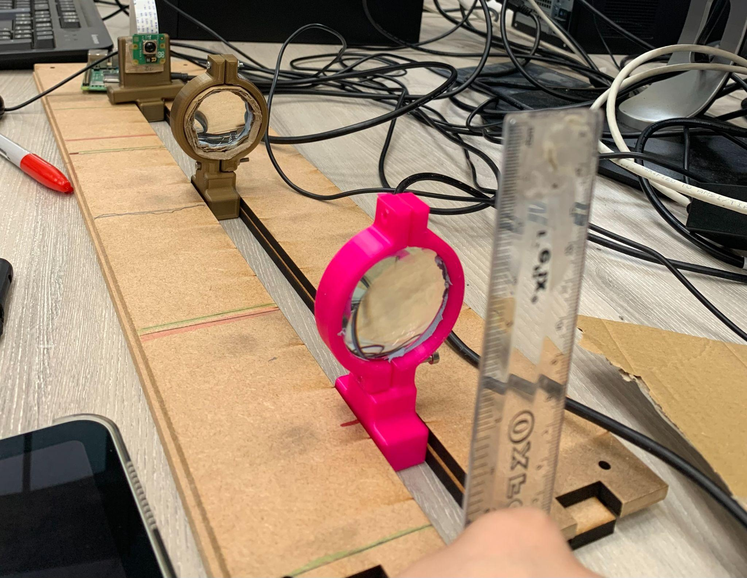

**Results:**

1. **Initial Design Setup**

| **Distance of Lens 1 (pink) from camera** | **243mm** | **196mm** | **141mm** | **104mm** | **168mm** |
| --- | --- | --- | --- | --- | --- |
| **Lens Image** |  |  |  |  |  |
| **Notes** | **No focussed image** | **No focussed image** | **No focussed image** | **No focussed image** | **Focussed at M=1** |

1. **Final Design Setup**

| **Distance of Lens 1 (pink) from camera** | **80mm** | **100mm** | **125mm** | **135mm** | **140mm** |
| --- | --- | --- | --- | --- | --- |
| **Lens Image** |  |  |  |  |  |
| **Notes** | Focussed  4mm visible | unfocussed | unfocussed | unfocussed | Focussed  10mm visible |